**Project Report: Grocery Web App**

**Introduction**

The **Grocery Web App** is a web-based platform designed to streamline online grocery shopping. The application offers customers the ability to browse, add, and manage grocery items while allowing administrators to manage products and orders efficiently.

1. **Objectives**

The primary objective of this project is to design and implement a functional food ordering platform using full-stack development skills. Key goals include:

* Provide a user-friendly online platform for grocery shopping.
* Facilitate product and order management for administrators.
* Ensure secure and seamless user authentication.

### ****2. Project Goals****

* **Convenience**: Make online grocery shopping easy and accessible for customers.
* **Efficiency**: Provide tools for administrators to manage product inventories and orders.
* **Security**: Ensure secure user authentication and data management.
* **Responsiveness**: Offer a seamless experience across devices.

### ****3. Technologies Used****

* **Frontend**: React.js for building a responsive and interactive user interface.
* **Backend**: Node.js with Express.js for handling server-side logic and APIs.
* **Database**: MongoDB for managing and storing data.
* **Additional Tools and Libraries**:
  + **State Management**: Redux for state handling.
  + **HTTP Requests**: Axios for API calls.
  + **Authentication**: JSON Web Tokens (JWT) for secure user sessions.
  + **CSS Frameworks**: Bootstrap and custom CSS for styling.

### ****4. System Architecture****

* **Frontend**: The client-side application is developed using React.js to create an interactive and dynamic user interface. It communicates with the backend through RESTful APIs.
* **Backend**: Node.js and Express.js handle API requests, interact with the database, and manage business logic.
* **Database**: MongoDB stores user information, product catalogs, and orders.

### ****5. Key Features****

* **User Authentication and Authorization**:
  + Users can register and log in securely using JWT-based authentication.

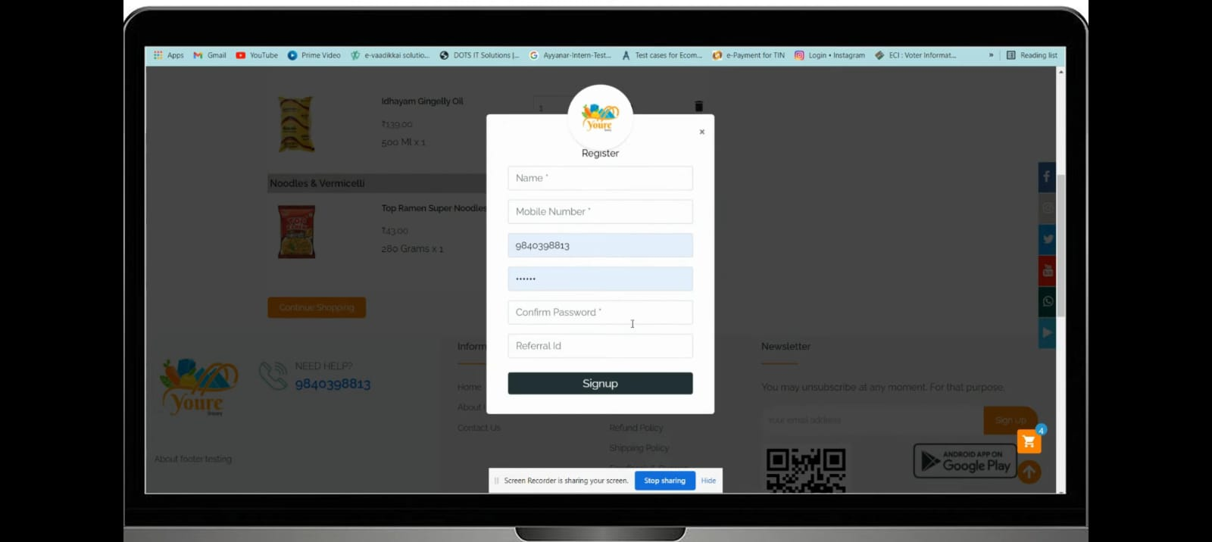

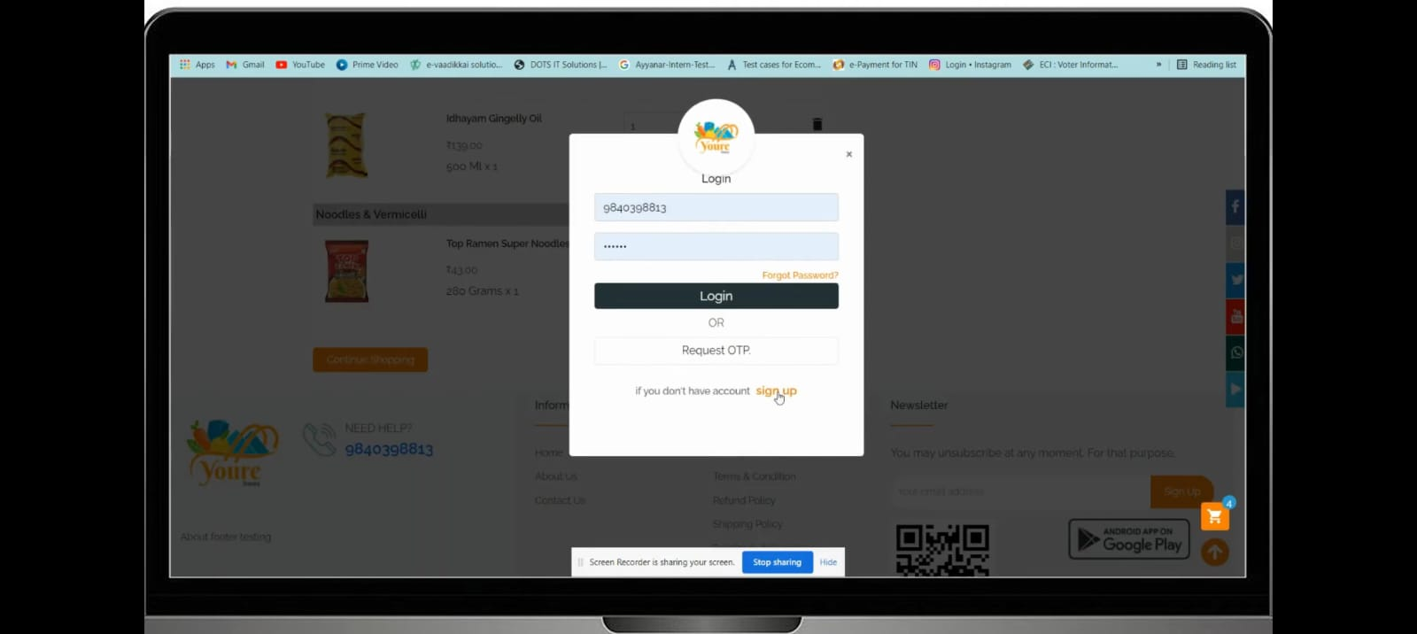

* **Product Management**:
  + Users can view and search products using filters and categories.
  + Products are displayed with details such as name, price, description, and availability.
  + 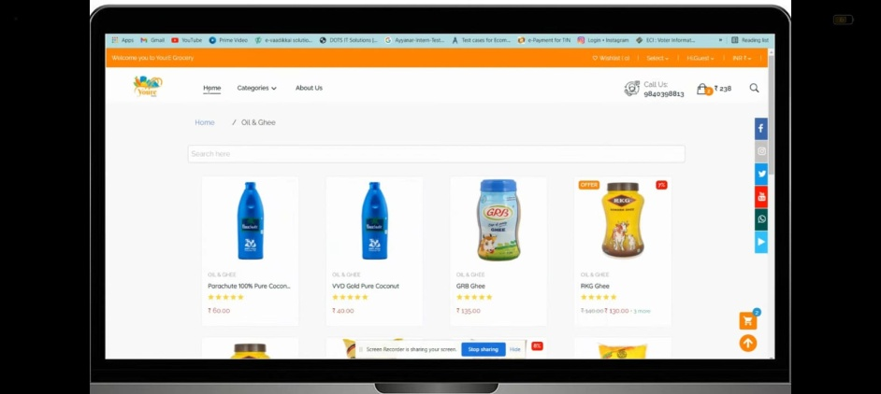
* **Shopping Cart**:
  + Users can add, remove, and update items in their shopping cart.

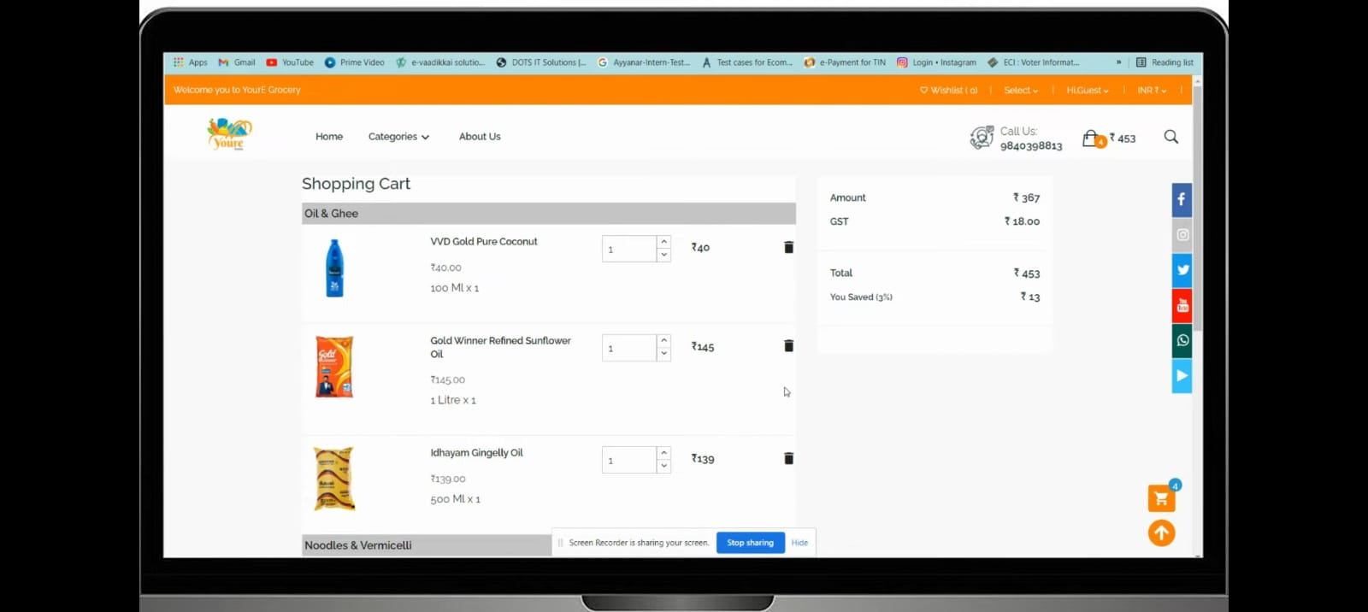

* **Order Management**:
  + Customers can place orders and track their status.
  + Admins can view and update order status.
* **Admin Panel**:
  + Admins have access to manage products (create, update, delete).
  + Order management functionality for updating order statuses.

### ****6. Application Workflow****

* **Customer Workflow**:
  1. Registration and Login
  2. Product Browsing and Filtering
  3. Adding Products to Cart
  4. Checkout and Order Placement
  5. Order Confirmation and Status Updates
* **Admin Workflow**:
  1. Login as Administrator
  2. Product Management (Add/Edit/Delete)
  3. Order Tracking and Status Updates

### ****7. Database Schema****

* **Users Collection**:
  + username (String)
  + password (String, encrypted)
  + email (String)
  + role (String: 'customer' or 'admin')
* **Products Collection**:
  + name (String)
  + description (String)
  + price (Number)
  + category (String)
  + quantity (Number)
* **Orders Collection**:
  + userId (Reference to Users collection)
  + products (Array of product details)
  + totalAmount (Number)
  + status (String: 'Pending', 'Shipped', etc.)
  + createdAt (Date)

### ****8. Challenges Faced****

* **State Management**: Handling complex state across multiple components using Redux.
* **Authentication**: Implementing secure JWT-based user sessions.
* **Performance Optimization**: Ensuring fast response times for API calls and page loads.
* **Responsive Design**: Adapting the UI for different screen sizes.

### ****9. Testing and Validation****

* **Unit Testing**: Performed unit testing on individual components and functions.
* **Integration Testing**: Verified seamless communication between frontend and backend components.
* **End-to-End Testing**: Tested the entire user journey to ensure a smooth and error-free experience.

### ****10. Future Enhancements****

* **Payment Integration**: Integrate secure payment gateways for online transactions.
* 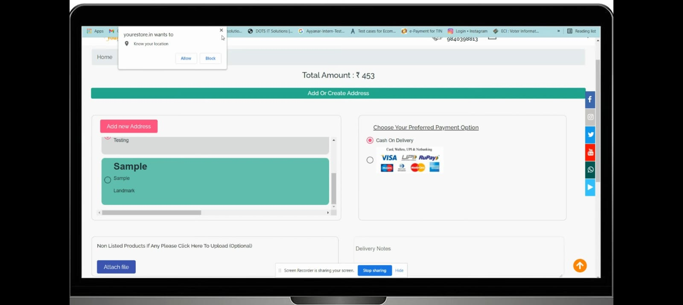
* **Advanced Filtering**: Implement additional filters like brand, rating, and price range.
* **Push Notifications**: Notify users about promotions, new products, and order status updates.
* **Mobile App**: Develop a mobile application to increase accessibility.

### ****11. Conclusion****

* **Summary**: The Grocery Web App effectively simplifies online grocery shopping and inventory management. With features like user authentication, product browsing, cart management, and administrative controls, it meets the needs of both customers and administrators.
* **Future Potential**: The application can be expanded with additional features and integrations to offer a more comprehensive and seamless shopping experience.